- \Operation\Tube filling\Settings
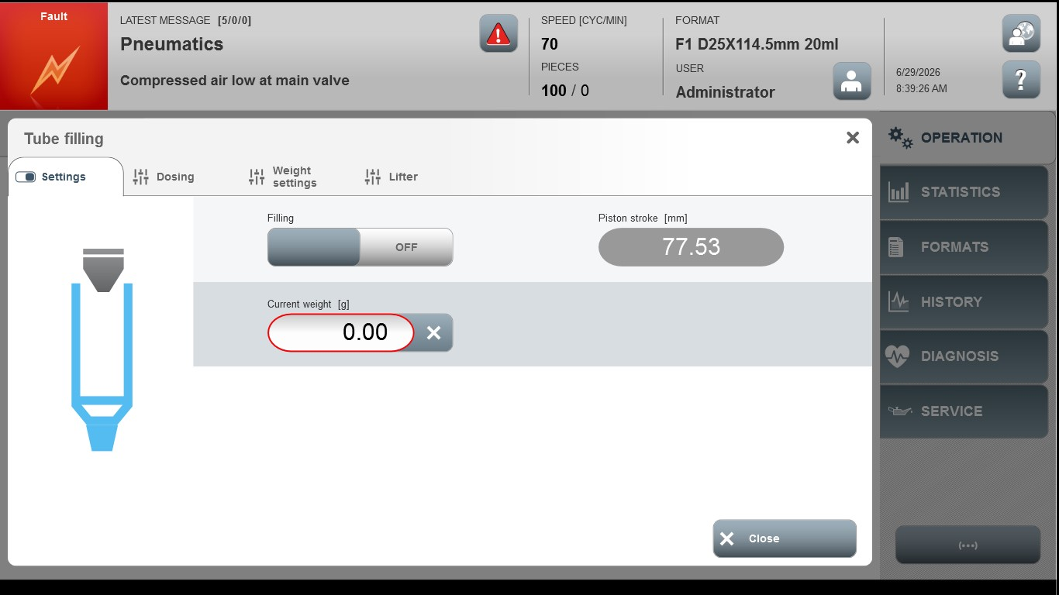
Acceptance criterion | Limits | Pass / Fail: Dev-No. | Date | Initials
Screen matches screenshot | N / A
Current weight [g] | Depending of format part

